**Stage 4 - Stage with no name**

**RULES:** USPSA Competition Rules, Latest Edition **COURSE DESIGNER:** Chuck Kuang

|  |  |
| --- | --- |
| **START POSITION:** See written stage briefing. | |
| **STAGE PROCEDURE**  See written stage briefing. | **SCORING**  **SCORING:** Comstock 24 rounds.  **TARGETS:** 11 cardboard targets, 2 steel targets  **SCORED HITS:** 2 Best hits per carboard will be scored. Steel must fall to score.  **START-STOP:**  Audible - Last shot  **PENALTIES:** Per USPSA Competition Rules |

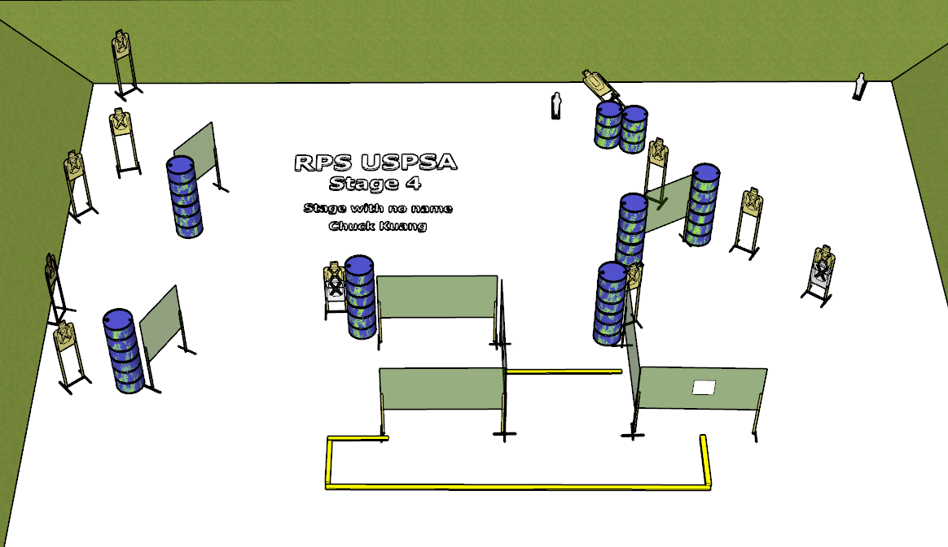

**Written Stage Briefing:**

**Stage 4 - Stage with no name-** is a 24-round, 120 point, Comstock Long Course. There are 11 cardboard targets and 2 steel targets. The best 2 hits per cardboard target will be scored. The steel must fall to score.

Activator Plate AP1 activates the Swinger target which remains visible at rest.

**Start position** Anywhere

**Handgun**: Loaded and holstered, wrists below belt.

**PCC**: Loaded, stock on belt.

On the audible start signal, engage targets from within the shooting area.

**USPSA / NROI Range Commands:**

* Make Ready
* Are you ready?
* Standby
* If finished, unload and show clear.
* If clear, hammer down and holster
* Range is clear

**Setup Notes:**

10 Single Wall Stands

3 Double Wall Stands

4 Full Walls

2 Ported Walls

3 Half Walls

10 Target stands

20 Target Sticks

1 Swinger

1 Activator Plate

1 mini popper

1 popper base

2 Moving Target sticks

14+ Barrels